**Created By**:- Suraj Chopade **Email:-** [**srj281191@gmail.com**](mailto:srj281191@gmail.com)

-------------------------------------------------------------------------------------------------------------------------------------------------------------------------------

**NGINX Name Based hosting:-**

**Domain:-** nixstock.in

**Subdomain:-** app1.nixstock.in && app2.nixstock.in

**NGINX Installation:-**

* Create repository file and add following content

# vim /etc/yum.repos.d/nginx.repo

**[nginx]**

name**=**nginx repo

baseurl**=**http://nginx.org/packages/mainline/rhel/7/$basearch/

gpgcheck**=**0

enabled**=**1

Clear yum database and install using yum

#yum install nginx -y

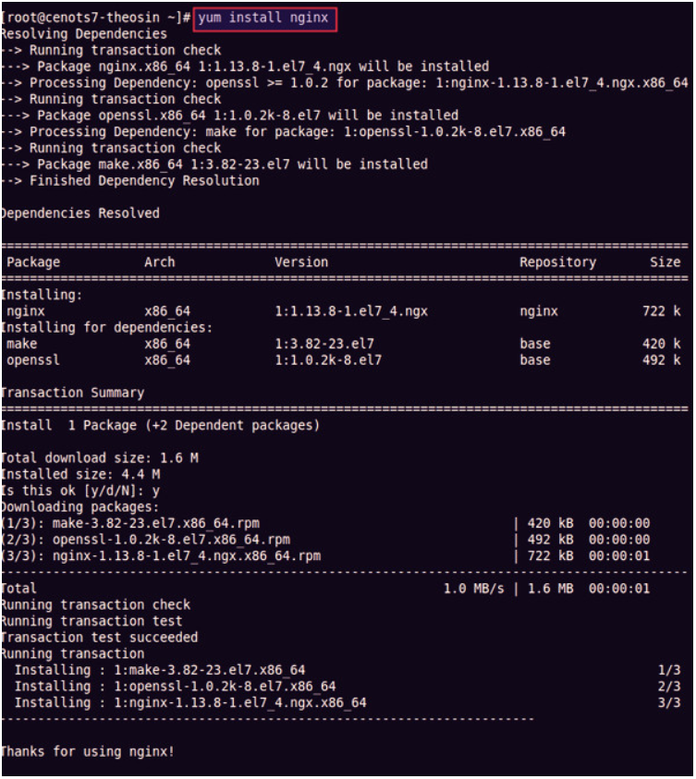

* Start the nginx service

# systemctl start nginx --now

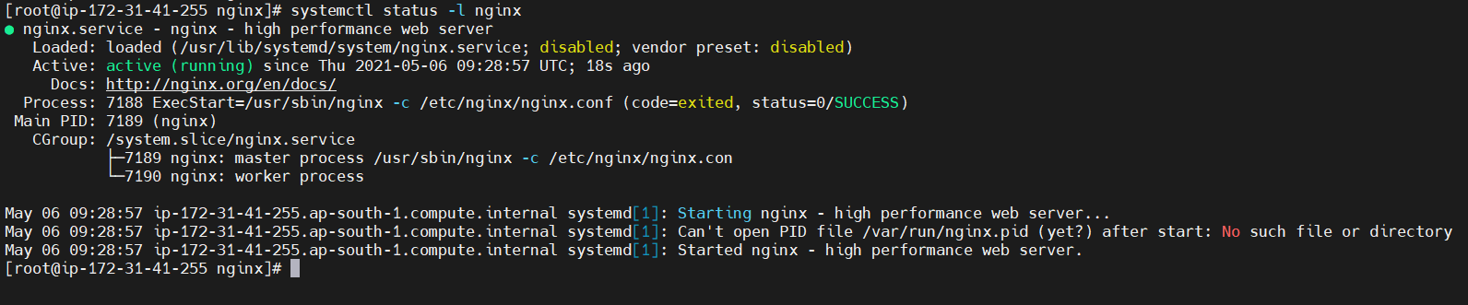

Now go into Document directory of NGINX as /usr/share/nginx/ and create two directories as follows and add a index.html page with vi editor

# mkdir -P app1.nixstock.in/html

# mkdir -P app2.nixstock.in/html

Once above directory structure created and the demo file added, we are ready to do the Virtual Host configuration in nginx.conf file.

# vim /etc/nginx/nginx.conf

Place following content in nginx.conf

server {

listen 80 default_server;

listen [::]:80 default_server;

root /usr/share/nginx/app1.padekar.live/html;

index index.html index.htm;

server_name app1.padekar.live;

}

server {

listen 80;

listen [::]:80;

root /usr/share/nginx/app2.padekar.live/html;

index index.html index.htm;

server_name app2.padekar.live;

}

* Restart the nginx service

# systemctl restart nginx.service

Verify the Websites using curl or on your browser.

**Note:- SeLinux should be disabled on with Permissive state. Use following command to do so**

1. Setenforce 0 ------------------------------> will set SeLinux as Permissive
2. Open file /etc/selinux/config and change the enforcing entry to disabled as follows

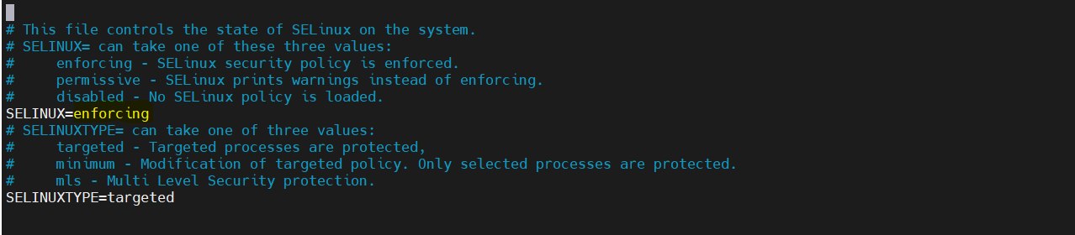

**Placing SSL certs using Letsencrypt for NGINX:-**

We are using certbot to install the SSL on the configured domain. Following link will give you steps to install the Certbot and map the SSL with your domain.

<https://certbot.eff.org/lets-encrypt/centosrhel7-apache.html>

Once the SSL installation is completed. Please check, the SSL configuration and http to https redirection is added in the nginx.conf file as shown in screenshot

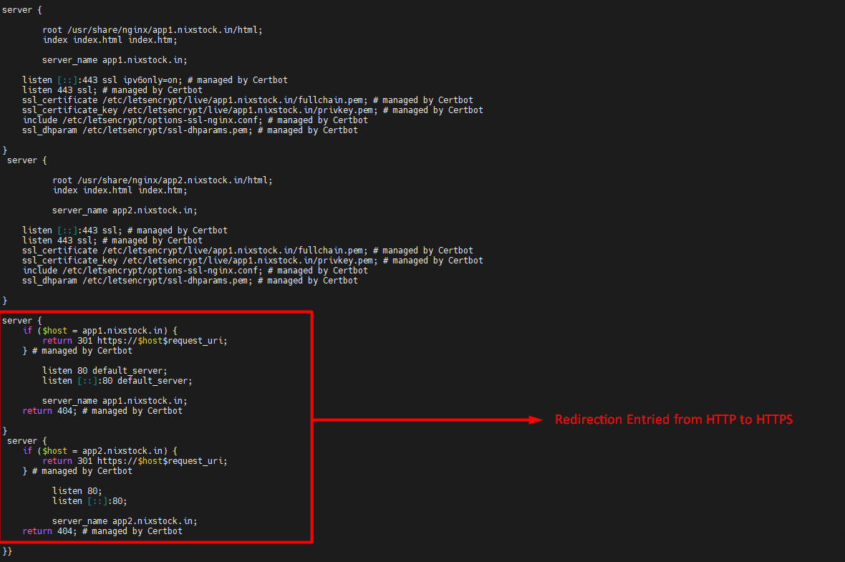

Verify the sites by accessing if the SSL termination and the redirection is working or not.

